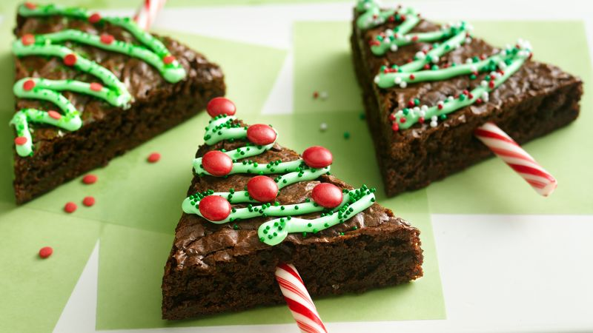**Holiday Tree Brownies**

* Prep30 MIN
* Total2 HR 40 MIN
* Servings15

Cut up brownies to create a fun holiday treat.

Yield = 15

Ingredients

* 1 box (1 lb 6.25 oz) Betty Crocker™ Supreme original brownie mix
* Water, vegetable oil and eggs called for on brownie mix box
* 2 or 3 drops green food color
* 2/3 cup Betty Crocker™ Rich & Creamy vanilla frosting (from 16-oz container)
* Betty Crocker™ Decorating Decors red and green candy sprinkles or miniature candy-coated chocolate baking bits
* Miniature candy canes (2 inch), unwrapped

Steps

1. Heat oven to 350°F (325°F for dark or nonstick pan). Line 9-inch square pan with foil so foil extends about 2 inches over sides of pan. Grease bottom only of foil with shortening or cooking spray.
2. Make brownie mix as directed on box for 9-inch square pan. Cool completely, about 1 1/2 hours. Remove from pan by lifting foil; peel foil away. To cut brownie into triangles, cut into 3 rows. Cut each row into 5 triangles (See diagram below in Expert Tips). Save smaller pieces for snacking.Stir food color into frosting. Spoon frosting into small resealable food-storage plastic bag; partially seal bag. Cut off tiny bottom corner of bag. Squeeze bag to pipe frosting over brownies. Sprinkle with decors.
3. Break off curved end of candy cane; insert straight piece into bottoms of triangles to make tree trunks.